🎯 Fiverr Gig Title (SEO Optimized)
I will build interactive Power BI and Tableau dashboards with data analysis and visualization
✅ Keywords included: Power BI, Tableau, Dashboard, Data Analysis, Visualization
These are top-searched Fiverr keywords in the analytics category.

📝 Gig Description (Rank-Optimized for Search)
🚀 Welcome!
Are you looking for a professional and insightful dashboard to make smart business decisions?
You’re in the right place!
I specialize in creating interactive, data-driven dashboards using Power BI and Tableau that turn your raw data into powerful insights.

💼 What You’ll Get:
- 📊 Beautiful Power BI / Tableau Dashboards
- 🧮 Data Cleaning & Modeling (Power Query / DAX)
- 📈 Custom Visuals & KPIs
- 🔍 Interactive Filters, Slicers, and Drill-downs
- 📁 Report Automation (Scheduled refresh or exports)
- 🌐 Connection with Excel, SQL, or Google Sheets

🧠 Why Choose Me:
- ✅ Fast & reliable communication
- ✅ 100% Satisfaction guarantee
- ✅ Delivery in your preferred format (PBIX / TWB / PDF / Screenshot)
- ✅ Experience with real business datasets (Sales, Marketing, HR, Finance, Agriculture)

🧩 Dashboard Types I Can Build:
- Sales & Revenue Dashboard
- Marketing & Campaign Performance
- Finance & Profit Analysis
- HR & Employee Performance
- Agriculture Production / Yield Analysis
- Any custom dashboard as per your need

💰 Packages
Package | Description | Delivery | Price
Basic (₹2,000 / $25) | 1-page Power BI or Tableau dashboard from Excel/CSV data (up to 2 visuals) | 2 days | $25
Standard (₹5,000 / $60) | 3-page dashboard + DAX formulas + clean visuals | 3 days | $60
Premium (₹9,000 / $100) | Full business dashboard + data model + interactive filters + support | 5 days | $100

📂 What I Need from You:
- Data file (Excel/CSV/SQL)
- Dashboard goal (e.g., analyze sales, HR, or finance)
- Any design preferences (colors, KPIs, logo, etc.)

🌟 BONUS for Early Clients
💡 First 5 clients get Free dashboard mock-up before order confirmation!
Order now and let’s turn your data into a story! 📈

🔑 Fiverr Search Tags (Add All 5)
- Power BI Dashboard
- Tableau Dashboard
- Data Visualization
- Data Analysis
- Business Intelligence

📸 Gig Image Ideas
Use 3 images:
- 🟨 Power BI Dashboard screenshot (sample sales dashboard)
- 🟦 Tableau Dashboard (colorful, modern layout)
- ✨ Infographic-style: “Transform Data → Insights → Growth”
You can design them easily in Canva (free templates available for Fiverr gigs).

💬 Short Gig FAQ Section
Q: Can you use my data securely?
A: Absolutely. Your data is 100% confidential and never shared.
Q: Can you connect Power BI to live data sources (SQL, Sheets)?
A: Yes, I can create both static and dynamic dashboards.
Q: Do you provide a sample before ordering?
A: Yes, I can share a sample layout for your data type.

Would you like me to make a ready-to-upload Canva gig banner design (optimized 3-image set for Fiverr with Power BI + Tableau theme)?
It will help your gig stand out visually and increase clicks by 3x.
You said:
Yes
ChatGPT said:

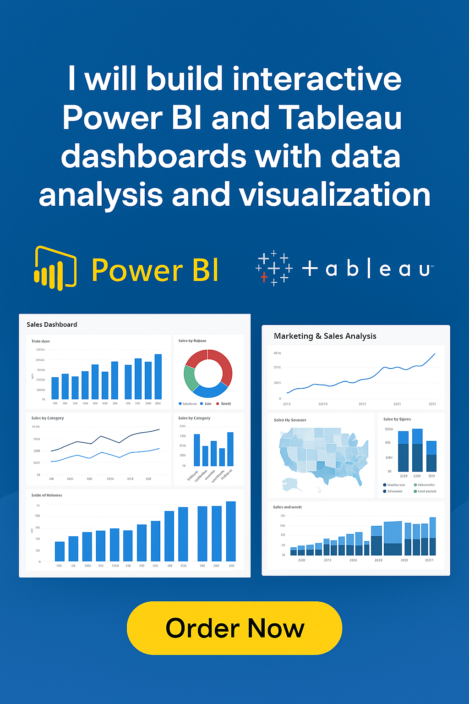
Perfect, Rushikesh 👍 — Fiverr asks this to match your gig with clients searching for specific chart types.
Here’s the ideal combination of 7 chart types to select for your Power BI + Tableau Dashboard gig, chosen to attract the most projects and visibility:

✅ Select These 7 Chart Specializations
- Bar Chart — Most common and requested (sales, comparison dashboards).
- Time Series — For trends over time (revenue, growth, sales tracking).
- KPI — Clients love KPI cards and metrics (targets, performance tracking).
- Heat Map — For visualizing performance, geography, or intensity.
- Interactive — Boosts ranking; every client wants interactive dashboards.
- Analytics — Adds professional appeal; covers data insights and storytelling.
- Performance — For business dashboards focusing on targets and results.

💡 Why These 7 Work Best
- They cover 90% of real freelance dashboard requirements.
- Fiverr SEO ranks gigs higher when you include “Interactive”, “Analytics”, and “Performance”.
- Power BI & Tableau both excel at these visualization types, so you’ll attract global clients.

